

V 1.1
July 2025
Functional & Technical XStep Specification
SMPL: Material Consumption

Table of Contents
Right-click and choose Update Field to build the table of contents.

Purpose
This document outlines the functional and technical design, along with the configuration specifications for the XStep “SMPL: Material Consumption”.

Overview
The SMPL:Material Consumption XStep facilitates and records the consumption of the use of raw materials, components, or consumables during production. This instruction ensures accurate and compliant documentation of materials used during batch execution, supporting GMP requirements and batch traceability.
This XStep includes the following functional coverage:
- Enter or capture actual material consumption values
- Link material usage to specific batches and process orders
- Apply system-driven checks for tolerances and batch validity
- Complete the material consumption step with an electronic signature
The XStep contains two main input parameters:
- IV_HEADER - This can be changed in SiMPL MBR to display specific header text for the XStep
- IV_INSTR - This can be changed in SiMPL MBR to display a specific set of instructions for the XStep that will be displayed below the header
- IV_TABLTIT - This can be changed in SiMPL MBR to display specific table header text for the XStep
- IV_SIGN – This can be changed in SiMPL MBR to author standalone signatures as part of the xstep.

Upon opening this XStep, the following information is automatically displayed:
- “Description” - Output
The operator enters the Part No, Batch No and Quantity:
- “Part no.” - Text Input
- “Batch no.” - Text Input
- “Exp. Date” - Output
- “Qty” - Text Input
Finally, the user who performed the step records their signature in the “Performed By” field.
For variant two, the following two fields are added:
- “Serial No.” - Text Input
- “Usage” - Text Input

Functional Design
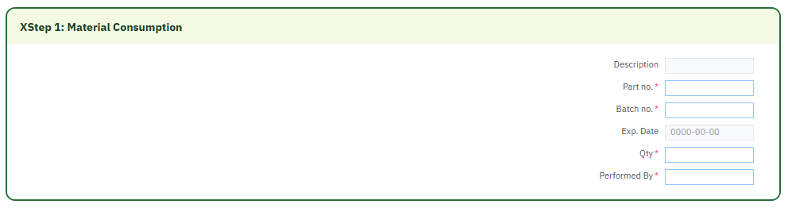
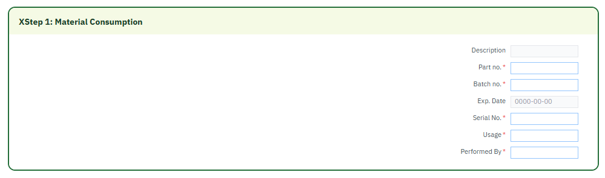

Reasons for developing
The development of the SMPL: Material Consumption XStep is required to:
- Automate the material consumption process directly within the batch record to ensure that component consumption is posted accurately and in real time.
- Capture part numbers, batch numbers and quantities electronically to support full traceability.
- Integrate the material consumption step into the production process to simplify the operator workflow by guiding them through required material movements within the same electronic record, reducing reliance on separate inventory transactions or paperwork.

Authorization
N/A

Assumptions/ Dependencies
 | Assumption
1 | User signing signature fields is an approved user in the system with the correct access configuration
2 | Material/batch validation logic is available to prevent incorrect or duplicate entries.
3 | Material/batch validation logic is available to prevent incorrect or duplicate entries across goods issue.

Validation Checks
Error Handling
Error | Action
No information retrieved in the table upon opening of XStep | Check master data / MBR configuration
User Signature rejected due to an incorrect username or password | User accepts error message and re-enter the correct username and password
Missing goods issue quantity | The operator must enter a value in the goods issue quantity column for each material line used in the operation.
Goods issue posting failure | Verify process order is valid, released and sufficient stock is available

XStep Layout Design
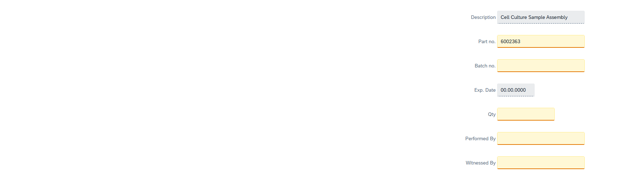

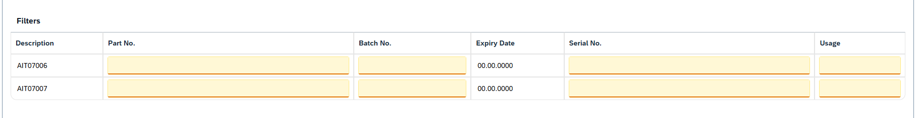

Function Module(s)
Function: /SMPL/PPPI_FM_GET_MAT_ITEMS
Import Parameters:
Parameter Name | Associated Type | Short Text
I_ORDER | AUFNR | Order Number
I_PHASE | VORNR | Activity Number (optional)
I_MATERIAL | MATNR | Material Number (optional)
I_BATCH | CHARG_D | Batch Number (optional)
I_COUNT | INT3 | Record count (optional)
I_FLAG | CHAR1 | Formatted-date flag (optional)

Export Parameters:
Parameter Name | Associated Type | Short Text
EV_MAT_DESC | MAKTX | Material Description
EV_BATCH | CHARG | Batch
EV_BOM_QUANTITY | ERFMG | BOM Quantity
EV_ISSUED_QUANTITY | ERFMG | Issued Quantity
EV_UOM | ERFME | Unit of Measure
EV_SERNR | SERNR | Serial Number
EV_CHAR_EXP_DT | CHAR10 | Expiry Date (formatted)
EV_EXP_DT | ETDATE | Expiry Date
EV_BATCHNO | CHARG_D | Batch Number

Exceptions:
Exception | Short Text
TOO_MANY_RECORDS | Too many records returned

Function: ZSMPL_FM_GET_MAT_ITEMS_EBR
Import Parameters:
Parameter Name | Associated Type | Short Text
I_ORDER | AUFNR | Order Number (optional)
I_PHASE | VORNR | Activity Number (optional)
I_MATERIAL | MATNR | Material Number (optional)
I_BATCH | CHARG_D | Batch Number (optional)
I_COUNT | INT3 | Record count (optional)
I_FLAG | CHAR1 | Formatted-date flag (optional)

Export Parameters:
Parameter Name | Associated Type | Short Text
EV_MAT_DESC | MAKTX | Material Description
EV_BATCH | CHARG | Batch
EV_BOM_QUANTITY | ERFMG | BOM Quantity
EV_ISSUED_QUANTITY | ERFMG | Issued Quantity
EV_UOM | ERFME | Unit of Measure
EV_SERNR | SERNR | Serial Number
EV_CHAR_EXP_DT | CHAR10 | Expiry Date (formatted)
EV_EXP_DT | ETDATE | Expiry Date
EV_BATCHNO | CHARG_D | Batch Number

Exceptions:
Exception | Short Text
TOO_MANY_RECORDS | Too many records returned

Function: /SMPL/PPPI_FM_INITIAL_ACTIVE
Import Parameters:
Parameter Name | Associated Type | Short Text
IV_ACTIVE | CHAR1 | N/A

Export Parameters:
Parameter Name | Associated Type | Short Text
EV_ACTIVE | CHAR1 | N/A

Function: /SMPL/MBR_DEP_CHECK_ACTIVE
Import Parameters:
Parameter Name | Associated Type | Short Text
IM_CONTROL_RECIPE | POC_DOCID | N/A
IM_PHASE | VORNR
IM_AUFNR | AUFNR
IM_STEP_UUID | /SMPL/MBR_SOG_UUID
IM_PLANT | WERKS_D

Export Parameters:
Parameter Name | Associated Type | Short Text
EV_ACTIVE | CHAR1 | N/A

Exceptions:
Exception | Short Text
CONTROL_RECIPE_INITIAL

Pseudocode
Function: /SMPL/PPPI_FM_GET_MAT_ITEMS
1. Purpose
Reads the process-order BOM components and returns each component’s description, batch, BOM/issued quantity, unit of measure and expiry date – used to populate and validate the Materials table.
2. Input Parameters
• I_ORDER – process order whose components are read.
• I_PHASE / I_BATCH – optional filters for activity and batch.
• I_MATERIAL / I_COUNT – optional material and record-count context.
• I_FLAG – when "X", the expiry date is returned as a formatted string.
3. Processing Logic
a. If the component buffer is empty, call BAPI_PROCORD_GET_DETAIL for I_ORDER to read the order components.
b. Filter the components by phase (I_PHASE) and batch (I_BATCH) when supplied.
c. For each component, read the batch expiry (VFDAT from MCH1); when I_FLAG = "X" return it formatted in EV_CHAR_EXP_DT, otherwise in EV_EXP_DT.
d. Return the material description, batch, BOM quantity, issued (withdrawn) quantity and UoM; default the quantities to 1 when the entry quantity is blank.
Output
• EV_MAT_DESC / EV_BATCH / EV_BATCHNO – component description and batch.
• EV_BOM_QUANTITY / EV_ISSUED_QUANTITY / EV_UOM – BOM and issued quantity with unit.
• EV_EXP_DT / EV_CHAR_EXP_DT – batch expiry date (raw or formatted).
Additional Notes
Error Handling:
• TOO_MANY_RECORDS – declared in the interface for multiple-match handling.
Dependencies:
• BAPI_PROCORD_GET_DETAIL; tables MCH1 (expiry) and MSEG (material document); GET_SERNOS_OF_DOCUMENT for serial numbers.
Assumptions:
• The order has BOM components; batch expiry is maintained in MCH1.

Function: ZSMPL_FM_GET_MAT_ITEMS_EBR
1. Purpose
EBR (Electronic Batch Record) variant of the material-items reader: returns each BOM component’s description, batch, BOM/issued quantity, UoM and expiry for the Materials table, reading the order components asynchronously when running in the EBR context.
2. Input Parameters
• I_ORDER – process order whose components are read (optional).
• I_PHASE / I_BATCH – optional filters for activity and batch.
• I_MATERIAL / I_COUNT – optional material and record-count context.
• I_FLAG – when "X", the expiry date is returned as a formatted string.
3. Processing Logic
a. If the component buffer is empty and the EBR websocket function is active (SMPL_EBR), call BAPI_PROCORD_GET_DETAIL via an asynchronous RFC task; otherwise call it synchronously.
b. Filter the buffered components by phase (I_PHASE) and batch (I_BATCH) when supplied.
c. For each component, read the batch expiry (VFDAT from MCH1); when I_FLAG = "X" return it formatted in EV_CHAR_EXP_DT, otherwise in EV_EXP_DT.
d. Return the material description, batch, BOM quantity, issued (withdrawn) quantity and UoM; default the quantities to 1 when the entry quantity is blank.
Output
• EV_MAT_DESC / EV_BATCH / EV_BATCHNO – component description and batch.
• EV_BOM_QUANTITY / EV_ISSUED_QUANTITY / EV_UOM – BOM and issued quantity with unit.
• EV_EXP_DT / EV_CHAR_EXP_DT – batch expiry date (raw or formatted).
Additional Notes
Error Handling:
• TOO_MANY_RECORDS – declared in the interface for multiple-match handling.
Dependencies:
• BAPI_PROCORD_GET_DETAIL (async RFC in EBR mode via /smpl/ebr_cl_apc_ws); table MCH1 for batch expiry.
Assumptions:
• The order has BOM components; in EBR mode the component buffer is populated by the asynchronous task before the table is filled.

Function: /SMPL/PPPI_FM_INITIAL_ACTIVE
1. Initialization
a. Input parameter IV_ACTIVE is optionally provided by the calling logic.
b. Constants gc_yes, gc_no, and gc_inside_range are assumed to be defined globally in the context of the function module.
2. Active Flag Evaluation
a. The function checks if the input value IV_ACTIVE falls within the expected valid range, represented by gc_inside_range.
b. Based on the result:
• If the input value is not equal to gc_inside_range, the XStep is marked as inactive by setting EV_ACTIVE = gc_no.
• If the input value is equal to gc_inside_range, the XStep is marked as active by setting EV_ACTIVE = gc_yes.
3. Output Assignment
a. The evaluated result is returned in the EV_ACTIVE export parameter for use by the calling logic (e.g., XStep configuration, PI sheet rendering).
Additional Notes
• This is a simple normalization function that abstracts how activation flags are interpreted for PPPI XSteps.
• The use of constants (gc_yes, gc_no, gc_inside_range) aligns the logic with broader application settings or standards.
• Input is optional, so defaulting behavior can be configured outside this function.

Function: /SMPL/MBR_DEP_CHECK_ACTIVE
1. Initialization
a. Input parameters provide context for determining whether an MBR step can be activated:
• IM_CONTROL_RECIPE (POC_DOCID) – Control recipe ID identifying the batch instruction.
• IM_PHASE (VORNR) (Optional) – Operation or phase within the process order.
• IM_AUFNR (AUFNR) (Optional) – Process order number associated with the step.
• IM_STEP_UUID (/SMPL/MBR_SOG_UUID) – Unique step identifier (SOG).
• IM_PLANT (WERKS_D) – Plant code for process context.
b. The function validates that IM_CONTROL_RECIPE is not initial; if it is, CONTROL_RECIPE_INITIAL is raised. Internal data is initialized and routine LOAD_INTERNAL_DATA populates the order dependency buffers.
2. Signature Data Retrieval
a. Signature records for the process order are retrieved from /SMPL/MBR_OR_SIG (AUFNR = IM_AUFNR) into internal table lt_ord_sigs for evaluation.
3. Dependency Evaluation
a. The function loops through dependencies where TARGET_UUID = IM_STEP_UUID and DEP_RULE is a Perform-Before-Start or Verify-Before-Start rule:
• For PERFORM BEFORE START, it checks whether the prerequisite step has a pending perform signature.
• For VERIFY BEFORE START, it checks whether the prerequisite step has a pending verify signature.
b. If an incomplete signature is found, the step is marked inactive (EV_ACTIVE = gc_step_inactive); if all prerequisites are complete, it is marked active (EV_ACTIVE = gc_step_active).
4. Output Assignment
a. The evaluated activation status is returned in EV_ACTIVE (active = all prerequisites complete; inactive = at least one prerequisite incomplete).
Additional Notes
• Evaluates Perform Before Start and Verify Before Start dependency rules using live signature data from /SMPL/MBR_OR_SIG.
• Error Handling: raises CONTROL_RECIPE_INITIAL if the control recipe is missing; handles empty dependency/signature data without runtime errors.
• Activation status is recalculated each time the function is called to reflect live signature data.

Configuration Specifications
Goods Issue (Z_PICONS)
The process message Z_PICONS is used to communicate goods issue data from the XStep execution to the backend system. This message handles material consumption postings (typically movement type 261) for the components used in production. During execution, the XStep collects and transfers relevant component data such as material number, batch, issued quantity, unit of measure, storage location, and any applicable scrap quantities. The message is triggered upon confirmation of the goods issue step and ensures that the component consumption is correctly reflected in the process order. All generated process messages are captured in transaction CO54, where they can be monitored and processed/sent. Configuration of Z_PICONS allows flexible mapping of input parameters and supports integration with both standard and custom logic for inventory updates and traceability.

Test Scenarios
Variant 1
# | Scenario | Expected Result | Actual Result | Pass/ Fail
1 | Create and Release a Process Order with the pre-configured SiMPL Master Recipe and the relevant Production Version | Process Order created and Released containing SMPL: Solution Summary - Data Recording
2 | Open the EBR, and navigate to SMPL: Material Consumption | The EBR for the selected Process Order and Control Recipe opens successfully without any errors and the SMPL: Material Consumption displays correctly.
3 | Verify that the Description displays correctly as authored from SiMPL MBR. | Description displays correctly.
4 | Enter a material or consumable part number. | Part number is accepted.
5 | Enter a valid Batch no. | Batch no. is accepted.
6 | Exp Date auto-populates based on the Material Master validation of the Part Number and Batch no. | Exp Date auto-populates correctly.
7 | Input value for Qty is entered. | Text value accepted.
8 | Enter a username in the “Performed By” field then enter the password in the pop-up window. | Signature is accepted
9 | Navigate to transaction CO54 to ensure process message is created successfully for goods consumption on the current order | Process message exists with the correct details.

Variant 2
# | Scenario | Expected Result | Actual Result | Pass/ Fail
1 | Create and Release a Process Order with the pre-configured SiMPL Master Recipe and the relevant Production Version | Process Order created and Released containing SMPL: Solution Summary - Data Recording
2 | Open the EBR, and navigate to SMPL: Material Consumption | The EBR for the selected Process Order and Control Recipe opens successfully without any errors and the SMPL: Material Consumption displays correctly.
3 | Verify that the Description displays correctly as authored from SiMPL MBR. | Description displays correctly.
4 | Enter a material or consumable part number. | Part number is accepted.
5 | Enter a valid Batch no. | Batch no. is accepted.
6 | Exp Date auto-populates based on the Material Master validation of the Part Number and Batch no. | Exp Date auto-populates correctly.
7 | Operator enters a value for the Serial No. | Serial No. text value is accepted.
8 | Operator enters the Usage value of the item | USage text value accepted.
9 | Enter a username in the “Performed By” field then enter the password in the pop-up window. | Signature is accepted
10 | Navigate to transaction CO54 to ensure process message is created successfully for goods consumption on the current order | Process message exists with the correct details.

Document References
Reference No. | Document Title
Number used in superscript for reference | Full name of referenced document
1 | SiMPL Functional Guide: Universal Concepts

Revision History
Version No. | Description | Author | Date
1.1 | Initial Document (Functional Requirements and Technical Specifications) | Frieda van der Merwe | 22-07-2025

